**SQL EXERCISE ADVANCED CONCEPTS**

**EX1.1 : Ranking and Window Functions**

USE RankingDemo;

GO

SELECT * FROM Products;

SELECT *

FROM (

SELECT *,

ROW_NUMBER() OVER (PARTITION BY Category ORDER BY Price DESC) AS RowNum

FROM Products

) AS Ranked

WHERE RowNum <= 3;

SELECT *

FROM (

SELECT *,

RANK() OVER (PARTITION BY Category ORDER BY Price DESC) AS RankNum

FROM Products

) AS Ranked

WHERE RankNum <= 3;

SELECT *

FROM (

SELECT *,

DENSE_RANK() OVER (PARTITION BY Category ORDER BY Price DESC) AS DenseRankNum

FROM Products

) AS Ranked

WHERE DenseRankNum <= 3;

OUTPUT

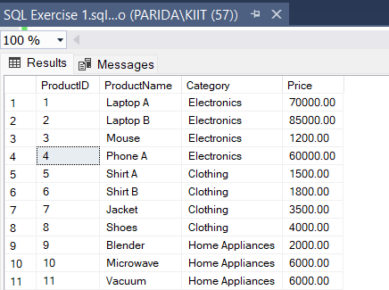 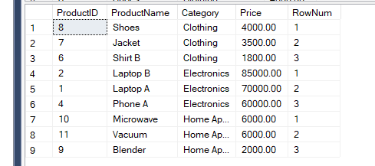

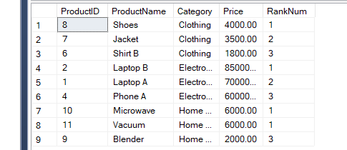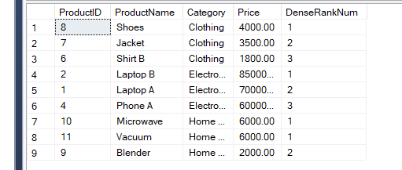

**SQL EXERCISE STORED PROCEDURE**

**EX4.1 : Create a Stored Procedure**

USE RankingDemo;

GO

DROP PROCEDURE IF EXISTS sp_InsertEmployee;

GO

CREATE PROCEDURE sp_InsertEmployee

@FirstName VARCHAR(50),

@LastName VARCHAR(50),

@DepartmentID INT,

@Salary DECIMAL(10,2),

@JoinDate DATE

AS

BEGIN

INSERT INTO Employees (FirstName, LastName, DepartmentID, Salary, JoinDate)

VALUES (@FirstName, @LastName, @DepartmentID, @Salary, @JoinDate);

END;

GO

EXEC sp_InsertEmployee

@FirstName = 'Raj',

@LastName = 'Sharma',

@DepartmentID = 101,

@Salary = 50000,

@JoinDate = '2024-05-01';

SELECT * FROM Employees;

**OUTPUT**

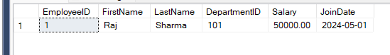

**EX4.5 : Return Data from a Stored Procedure**

USE RankingDemo;

GO

DROP PROCEDURE IF EXISTS sp_GetEmployeeCountByDept;

GO

CREATE PROCEDURE sp_GetEmployeeCountByDept

@DeptID INT

AS

BEGIN

SELECT COUNT(*) AS TotalEmployees

FROM Employees

WHERE DepartmentID = @DeptID;

END;

GO

-- Raj Sharma - Dept 102

EXEC sp_InsertEmployee

@FirstName = 'Raj',

@LastName = 'Sharma',

@DepartmentID = 102,

@Salary = 60000,

@JoinDate = '2024-04-15';

-- Priya Das - Dept 102

EXEC sp_InsertEmployee

@FirstName = 'Priya',

@LastName = 'Das',

@DepartmentID = 102,

@Salary = 58000,

@JoinDate = '2024-03-12';

-- Amit Roy - Dept 101

EXEC sp_InsertEmployee

@FirstName = 'Amit',

@LastName = 'Roy',

@DepartmentID = 101,

@Salary = 65000,

@JoinDate = '2023-11-01';

-- Sneha Kapoor - Dept 103

EXEC sp_InsertEmployee

@FirstName = 'Sneha',

@LastName = 'Kapoor',

@DepartmentID = 103,

@Salary = 72000,

@JoinDate = '2022-09-20';

-- Rohan Mehta - Dept 101

EXEC sp_InsertEmployee

@FirstName = 'Rohan',

@LastName = 'Mehta',

@DepartmentID = 101,

@Salary = 55000,

@JoinDate = '2023-06-10';

GO

EXEC sp_GetEmployeeCountByDept @DeptID = 102;

GO

SELECT * FROM Employees;

GO

**OUTPUT**

